IA-2

Unit-2

**Types of estimates**

1. Order of magnitude estimate
2. Study estimate
3. Preliminary estimate
4. Definitive estimate
5. Detailed estimate

**Order of magnitude estimate 🡪 Accuracy = +-60%**

1. **Investment per annual ton capacity**

If installed cost of plant P1 of annual ton capacity C1 is rupees R1 then for plant P2 having annual ton capacity the rupees investment would be…



1. **Turn-over ratio and capital ratio**

Ratio between annual sales and investment expressed in rupees is known as ***turn-over ratio***. And its reverse is known as ***capital ratio***.

1. **Six-tenth factor**

Plant investment is assumed to vary as 0.6 power of the plant size. Thus, estimated cost R2 for the new plant can be computed as



1. **Inflation index**

An estimate to find if the capacity remains the same as that of installed in past.

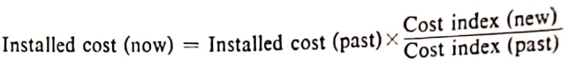

1. **Location index**

*Knowing the plant cost in USA or other country*, ***the cost of same plant in India or any other country*** can be estimated using this index.

**Study estimate 🡪 Accuracy = +-30%**

* This estimate is for studying ~~economic viability~~ **profit** of the project and arranging funds for the project.
* At this stage all the amenities is obtained from ~~process licensor~~ **agent**.
* Total plant cost is found by multiplying total equipment cost by a factor known as **lang factor**.

**Preliminary estimate 🡪 Accuracy = +-20%**

* Also called as **rough or approximate estimates**
* Gives an idea of how much the project will cost
* As the project is under the development phase (**Effective Start Date** or **Zero Date**), estimation of new equipments can be made with accuracy.
* The budget allocation is frozen at this stage

**Definitive estimate 🡪 Accuracy = +-10%**

* This estimate is prepared after Zero Date
* Equipments purchase cost are done with accuracy.
* Items for labor’s cost is estimated

**Detailed estimate 🡪 Accuracy = +-5%**

* This estimate is done on successful completion of the equipment/project
* The additional information available at this stage is…
  + 1. Value of plant equipment and machinery
    2. Cost of all major contracts
    3. Final market take-offs
    4. 90% construction drawings

Evaluation of project profitability

1. Pay Back Period
2. Return on investment
3. Net Present Value
4. Internal Rate of Return
5. Benefit Cost Ratio

Matrix Organisation

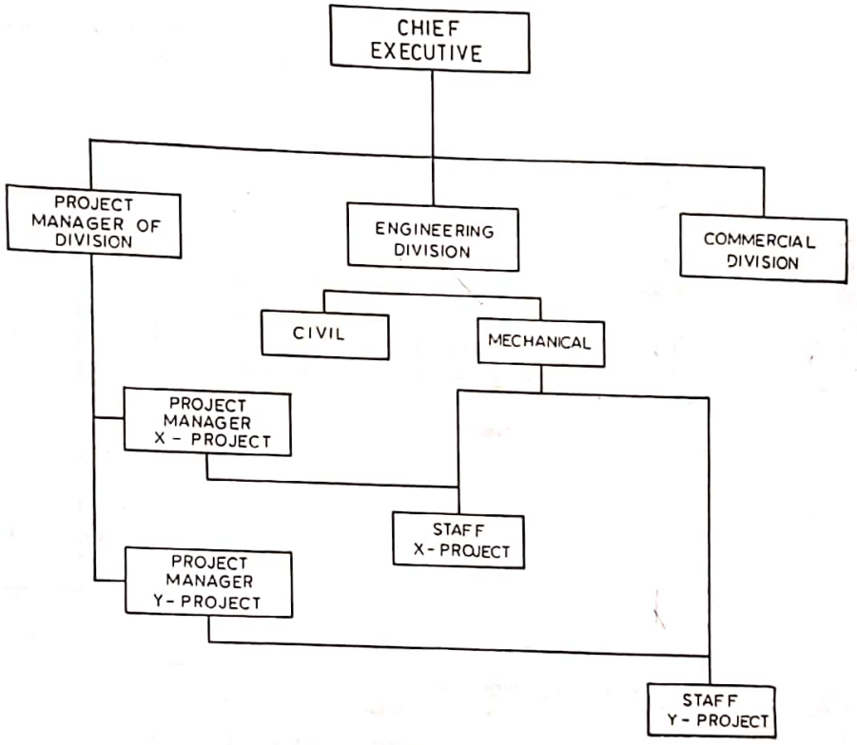

**Definition:**

A company structure where teams report to multiple leaders. **OR**

A structure where there is more than one line of reporting managers.

Task Force Organisation

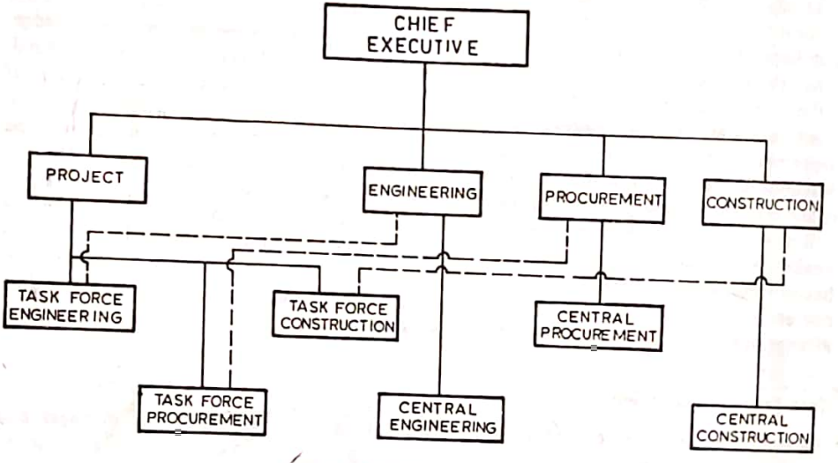

**Contractors**

**Definition**

A self-employed worker who operates independently on a contract basis.

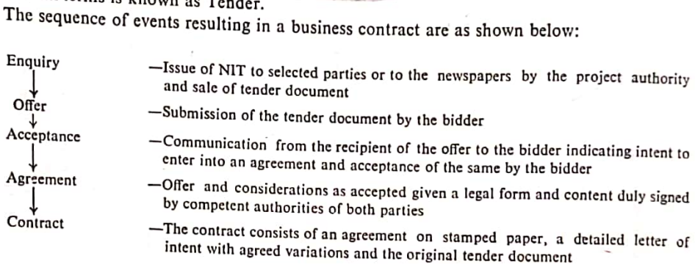

**3 ‘R’s of contracting**

Responsibility

Reimbursement

Risk

**Tendering and selection of Contractor**